EXPERIMENT-1

Design and configure the hub network using cisco packet tracer

Aim:

To design and configure a LAN using one Hub and five PCs in Cisco Packet Tracer using Class A IP addresses.

Procedure
- Open Cisco Packet Tracer
- Drag and place 1 Hub from Network Devices
- Drag and place 5 PCs from End Devices
- Connect each PC to the Hub using Copper Straight-Through cables
- Click on PC1 → Desktop → IP Configuration
- Assign Class A IP addresses as follows: ○ PC1: 10.0.0.1

○ PC2: 10.0.0.2

○ PC3: 10.0.0.3

○ PC4: 10.0.0.4

○ PC5: 10.0.0.5

○ Subnet Mask (all PCs): 255.0.0.0

- Close IP configuration window after assigning IPs

- Open Command Prompt on any PC

- Use the ping command to ping another PC’s IP address

- Verify that reply is received

DIAGRAM

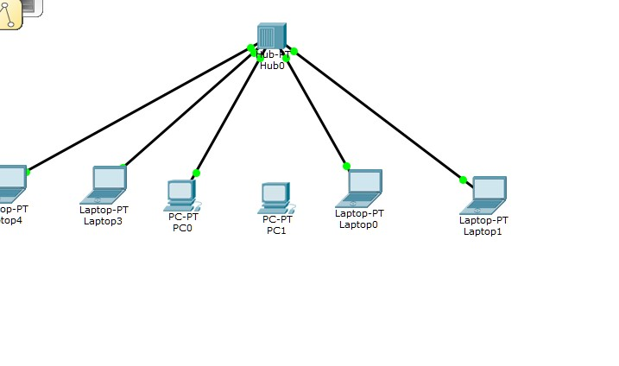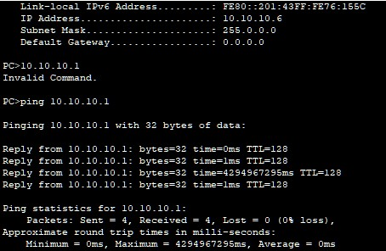

OBSERVATION:
- All five PCs were properly connected to the hub.

- Class A IP addresses were assigned correctly to each PC.

- Same subnet mask was used for all PCs.

- The hub successfully allowed communication between all PCs.

- Ping command showed reply messages between PCs.

- This confirms that the LAN was configured correctly and is working properly.

Result:

The LAN using a hub and five PCs was successfully configured, and network connectivity was

verified using the ping command.
EXPERIMENT-2
Design and configure the Switch network using cisco packet tracer
Aim:
To design and simulate a Local Area Network (LAN) using switches in Cisco Packet Tracer and verify end-to-end connectivity between multiple PCs using the ping command.
Procedure:
- Open Cisco Packet Tracer
- Place Network Devices
  - From End Devices, add required PCs and Laptops to the workspace.
  - From Network Devices → Switches, add two 2950/2960 switches.
- Connect End Devices to Switches
- Connect Switch to Switch
  - Use a Copper Cross -Over cable.
  - Connect FastEthernet port of Switch0 to FastEthernet port of Switch1.
- Assign IP Addresses
  - Click each PC/Laptop → Desktop → IP Configuration.
  - Assign IP addresses in the same network.
  - Example:
    - PC0: 11.10.1.1 / 255.255.255.0 ii. PC1: 11.10.1.2 / 255.255.255.0 iii. PC2: 11.10.1.3 / 255.255.255.0
  - Leave Default Gateway blank (no router used).
- Check Physical Connections
  - Ensure all cable indicators turn green, showing active links.
- Verify Connectivity
- Observe Results
  - Successful replies indicate proper connectivity.
  - If requests time out:
    - Verify IP addresses
    - Ensure same subnet
    - Check cable types and switch ports

DIAGRAM:
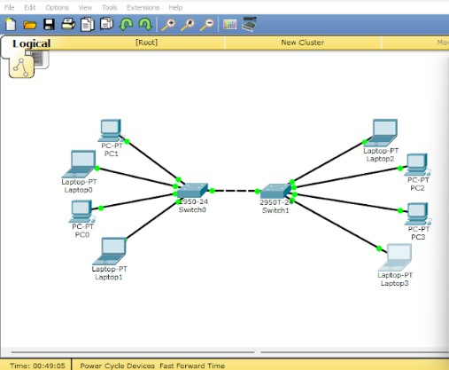

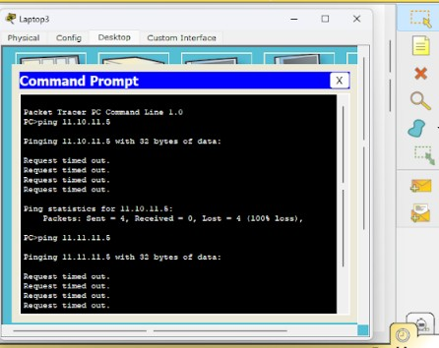

OBSERVATION:

- A LAN was designed using switches in Cisco Packet Tracer.
- Multiple PCs were connected to switches using appropriate cables.
- IP addresses were assigned within the same network.
- No router or default gateway was required.
- Switch-to-switch communication enabled data transfer between PCs.
- Connectivity was tested using the ping command.
- Successful ping replies confirmed proper network connectivity.

RESULT:

The LAN was successfully designed and all connected PCs communicated with each other without errors.

EXPERIMENT-3

DESIGN A VIRTUAL LAN FOR LAN 1.A AND LAN 2.B

AIM :

To design and configure a Virtual Local Area Network (VLAN) for AIML and CSD departments

located in Block-A and Block-B using switches, such that faculty members of the same

department are logically grouped in the same LAN while maintaining separate broadcast

omains, and to verify connectivity using PDU packets in Cisco Packet Tracer.

PROCEDURE :

- Open Packet Tracer: Start the software and clear your workspace.
- Add Switches: Place two switches and name them Block-A and Block-B.
- Add PCs: Place two PCs at each switch for AIML and CSD faculty.
- Connect PCs: Use Straight-Through cables to connect each PC to its switch.
- Connect Switches: Link Switch-A to Switch-B using a Cross-Over cable.
- Create VLANs (Switch-A): Open the CLI and create VLAN 10 (AIML) and VLAN 20
(CSD).
- Create VLANs (Switch-B): Repeat the same VLAN creation (10 and 20) on the second switch.
- Assign Ports: Map the AIML PC ports to VLAN 10 and CSD PC ports to VLAN 20 on both switches.
- Set Trunking: Configure the link between the two switches as a Trunk port.
- Set IPs: Give each PC an IP address (PCs in the same VLAN must be in the same network).
- Test Mode: Enter Simulation Mode and use the Add Simple PDU (envelope icon) tool.
- Verify: * Success: AIML to AIML / CSD to CSD.
○ Fail: AIML to CSD.
DIAGRAM:
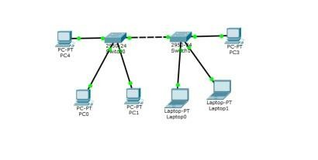

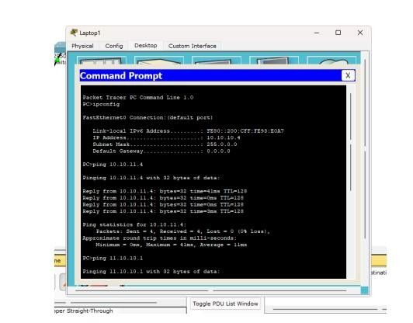

Observation

- VLAN 10 (AIML) and VLAN 20 (CSD) were created successfully on both switches.
- PCs in the same VLAN communicated successfully across Block-A and Block-B.
- The trunk link allowed VLAN traffic to pass between the two switches.

- PCs in different VLANs could not communicate with each other.
- This shows that VLANs create separate broadcast domains in the network.

RESULT:

A LAN was successfully created using a Switch-PT and five PCs. All systems were assigned
Class A IP addresses with the subnet mask 255.0.0.0, placing them in the same subnet.
Communication between all PCs was verified successfully using the ping command.

EXPERIMENT - 4

PROTOCOLS LEARNINGS IN DETAIL USING WIRESHARK FILTER AND FLOW GRAPH

Aim
To capture, identify, and analyze various network protocols using Wireshark and to study at least five important protocols (TCP, UDP, ARP, ICMP, HTTP) in detail using display filters and flow graphs.

Requirements
- System with Internet connectivity

- Wireshark installed

- Web browser

- Command Prompt / Terminal

Procedure
- Install and open Wireshark on the system.

- Select the active network interface (Wi-Fi/Ethernet).

- Click on Start Capture to begin packet capturing.

- Generate network traffic by browsing a website or using commands like ping and nslookup.

- Stop the packet capture after sufficient packets are recorded.

- Apply display filters such as tcp, udp, arp, icmp, and http to analyze specific protocols.

- Select individual packets to examine header details in the packet details pane.

- Use Follow → TCP Stream to observe complete TCP communication.

- Open Statistics → Flow Graph to visualize packet flow between source and destination.

- Analyze the captured packets and record observations for each protocol.

OUTPUT

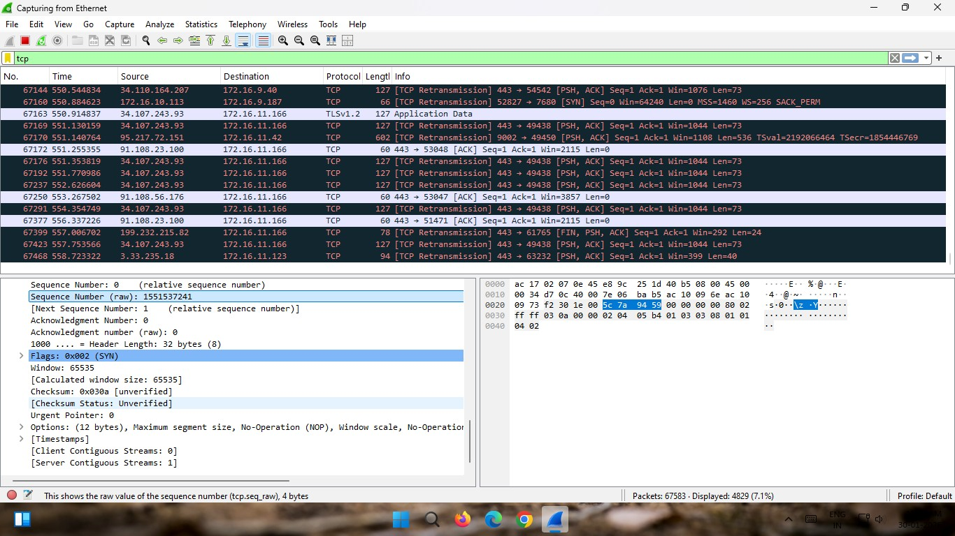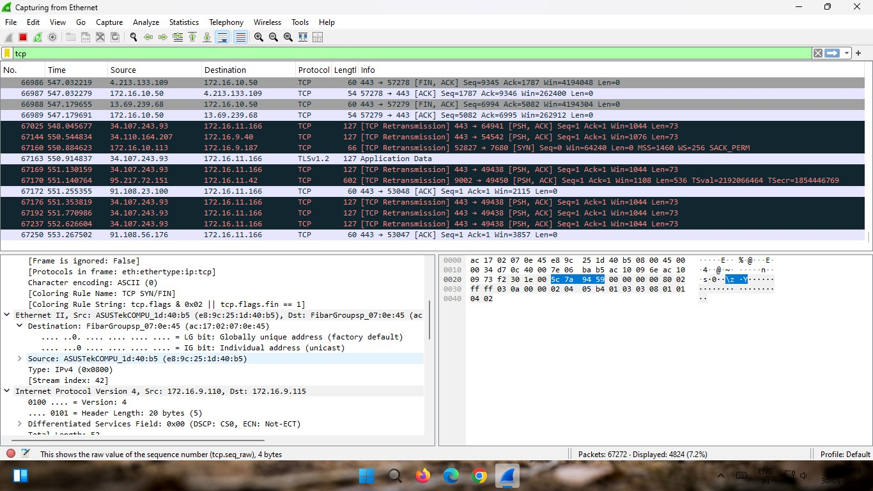

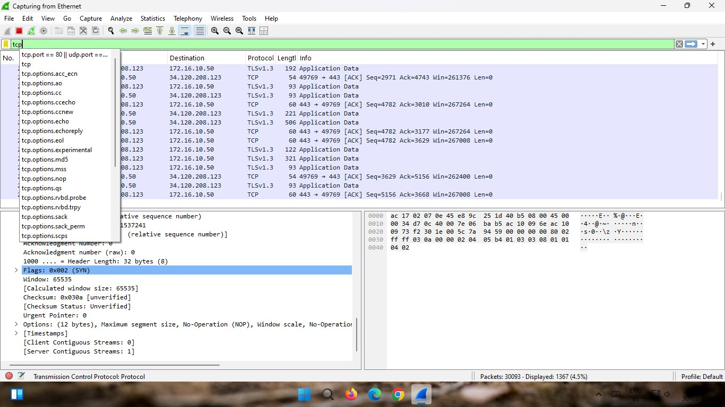

Observation
- TCP showed three steps before sending data (SYN, SYN-ACK, ACK).

- UDP sent data directly without any connection setup.

- ARP asked for a MAC address and received a reply.

- ICMP showed request and reply packets during ping.

- HTTP showed website request and server response.

RESULT
The network protocols TCP, UDP, ARP, ICMP, and HTTP were successfully captured and analyzed using Wireshark. The packet details, filters, and flow graph helped in understanding how data is transmitted between source and destination. The working and behavior of each protocol were studied clearly and verified.

EXPERIMENT - 5

IMPLEMENTING A HAMMING CODE SENDER PROGRAM

Aim
To design a Hamming Code sender utility and to generate an error-detecting bitstream using even parity.

Procedure
- Input the binary data string.
- Calculate required check bits using 2r≥m+r+12^r \geq m + r + 12r≥m+r+1.
- Place check bits at positions 1, 2, 4, 8, etc.
- Insert data bits in remaining positions.
- Assign each data bit to check bit groups based on binary position.
- Compute check bits to maintain even parity.
- Combine all bits to form final encoded bitstream.

Program
def calculate_parity_bits(m):
p = 0
while (2**p) < m + p + 1:
p += 1
return p

def position_parity_bits(data, p):
j = 0
k = 1
m = len(data)
result = ""
for i in range(1, m + p + 1):
if i == 2**j:
result += "0"
j += 1
else:
result += data[-k]
k += 1
return result[::-1]

def calculate_parity_values(code, p):
n = len(code)
for i in range(p):
val = 0
for j in range(1, n + 1):
if j & (2**i) == (2**i):
val = val ^ int(code[-j])
code = code[: n - (2**i)] + str(val) + code[n - (2**i) + 1 :]
return code

def detect_correct_error(code, p):
n = len(code)
error_pos = 0
for i in range(p):
val = 0
for j in range(1, n + 1):
if j & (2**i) == (2**i):
val = val ^ int(code[-j])
error_pos += val * (2**i)

if error_pos:
print(f"Error found at position: {error_pos}")
corrected_code = (
code[: n - error_pos]
+ str(1 - int(code[n - error_pos]))
+ code[n - error_pos + 1 :]
)
return corrected_code
else:
print("No error detected.")
return code

def main():
original_data = input("Enter the data bits: ")
m = len(original_data)
p = calculate_parity_bits(m)
positioned_data = position_parity_bits(original_data, p)
hamming_code = calculate_parity_values(positioned_data, p)
print(f"Hamming Code: {hamming_code}")

received_code = input("Enter the received Hamming Code: ")
corrected_code = detect_correct_error(received_code, p)
print(f"Corrected Hamming Code: {corrected_code}")

if __name__ == "__main__":
main()

Output
Enter the data bits: 1001010
Hamming Code: 10011010001 Enter the received Hamming Code: 10011010001 No error detected. Corrected Hamming Code: 10011010001

Observation
- The data length increases from 4 bits to 7 bits due to added check bits.
- Check bits are placed at positions 1, 2, and 4, forming a structured pattern.
- Each check bit covers multiple data bits, creating overlapping groups.
- Even parity maintains a balanced number of 1s in each group.
- The final encoded output is 0110011, ensuring error detection capability.
Result
Hamming code successfully generated with even parity.

EXPERIMENT-6

SLIDING WINDOW

Aim
To simulate the Sliding Window Protocol for data transmission.

Procedure
- Start the program.
- Input the window size (w).
- Enter the number of frames (f) to be transmitted.
- Input the sequence of frames.
- The sender transmits frames in groups equal to the window size.
- After sending each window, the sender waits for acknowledgement.
- Continue until all frames are transmitted.

Output

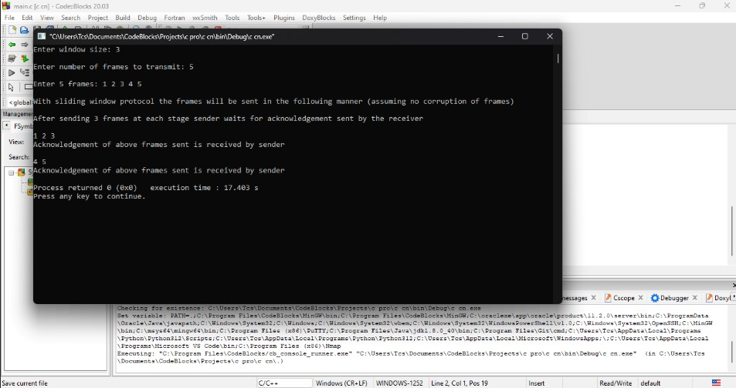

Observation

- Frames are sent in groups based on window size.
- Acknowledgement is received after each group of frames.
- Sender waits only after sending a full window.
- Remaining frames are sent if frames are not multiple of window size.
- Transmission efficiency is improved compared to one-by-one sending.

Result

Sliding Window Protocol is successfully simulated with efficient frame transmission using grouped acknowledgements.

EXPERIMENT-7

SUBNETTING

Aim
To design and configure 2 subnets from the given network 192.168.10.0/25.

Procedure
- Given network: 192.168.10.0/25 (128 IP addresses).
- Divide the network into 2 equal subnets.
- Subnet mask becomes /26 (255.255.255.192).
- Subnet 1:
  - Network ID: 192.168.10.0/26
○ Usable IPs: 192.168.10.1 – 192.168.10.62
- Subnet 2:
  - Network ID: 192.168.10.64/26
○ Usable IPs: 192.168.10.65 – 192.168.10.126 6. Assign at least 3 IP addresses to computers in each subnet.
- Configure IP address and subnet mask in each system.
- Use a router or switch to connect subnets.
- Send PDU (ping) packets to test connectivity.

Output

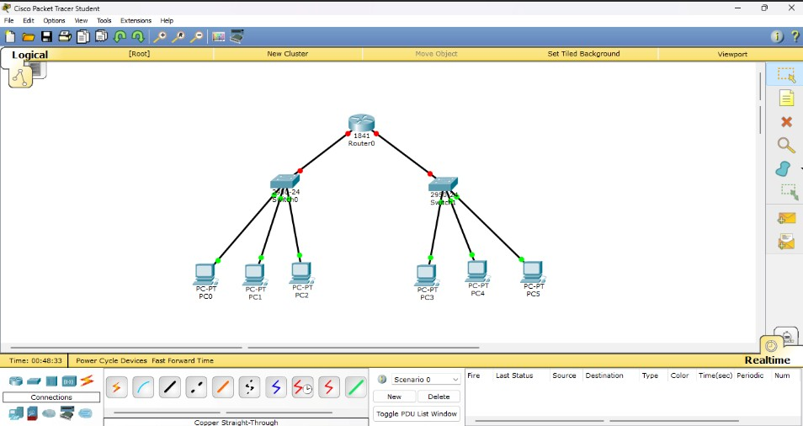

Observation
- The given network is successfully divided into two equal subnets.
- Each subnet supports more than 3 computers.
- Devices within the same subnet communicate directly.
- Communication between subnets requires routing.
- PDU packets confirm successful data transmission.

Result
Thus Subnets are successfully created and configured.

EXPERIMENT-8

TCP/UDP SOCKETS

Aim
To implement an Echo Client-Server communication using TCP and UDP sockets in Java, where the client sends a message and the server echoes it back.

Procedure
- Start the program execution.
- Create a server program:
  - For TCP, initialize a ServerSocket with a port number.
○ For UDP, initialize a DatagramSocket with a port number.
- Wait for client communication:
  - In TCP, accept the client connection using accept().
○ In UDP, wait to receive a packet using receive().
- Create a client program:
  - For TCP, establish connection using Socket with server IP and port.
○ For UDP, create a DatagramSocket and prepare a packet with server address.
- Send message from client to server.
- Receive the message at the server side.
- Echo the same message back to the client:
  - In TCP, send via output stream.
○ In UDP, send using DatagramPacket.
- Receive echoed message at the client side and display it.
- Repeat communication if required until termination. ● Close all sockets and end the program.

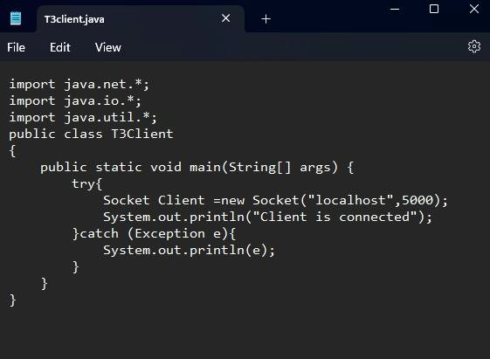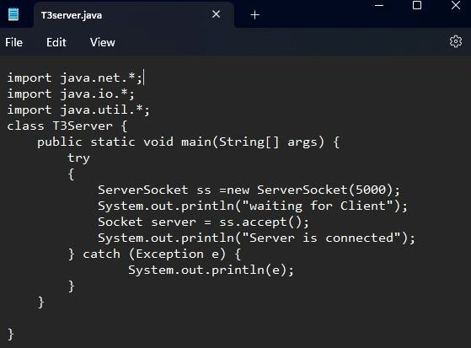

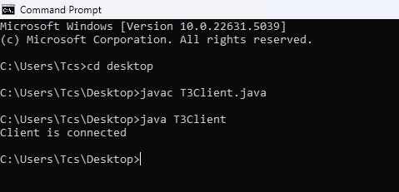

Observation
- In TCP, connection is established before communication.
- Messages are delivered reliably and in order.
- In UDP, no connection setup is required.
- Data may be faster but not guaranteed to reach.
- Both programs successfully echoed client messages.

Result
The Echo Client-Server programs using both TCP and UDP sockets were successfully implemented and executed. The server correctly received messages from the client and sent back the same message as output.

EXPERIMENT-9

WIRELESS ROUTER

Aim
To study and configure a wireless router and establish a wireless network connection between devices.

Procedure
- Switch on the wireless router and connect it to the power supply.
- Connect the router to the internet source (modem or ISP cable).
- Use a computer/mobile device to search for available Wi-Fi networks.
- Connect to the router’s default SSID (network name).
- Open a web browser and enter the router’s IP address (e.g., 192.168.1.1).
- Log in using default username and password.
- Configure basic settings:
○ Change SSID (network name).
○ Set a secure password (WPA2/WPA3).
- Save settings and restart the router if required.
- Reconnect devices using the new SSID and password.
- Test the connection by accessing websites or transferring data.

Output
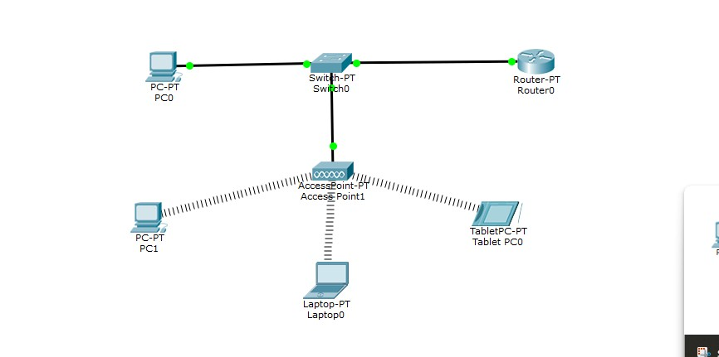

Observation

- The wireless router broadcasts an SSID that devices can detect.
- Devices successfully connected using the configured password.
- Data transmission occurred without physical cables.
- Network speed and signal strength varied based on distance and obstacles.

Result

The wireless router was successfully configured, and a stable wireless network connection was established between devices, enabling internet access and communication.

